Remote Motor Controller

## What’s the project about?

This project is about to agricultural applications in which it will reduce the farmer efforts by controlling the pump remotely via mobile application.

## Tasks to achieve?

### Hardware design

Casing/boxing   
PCB Board

### Software design

Firmware development   
App development

## Bock diagram

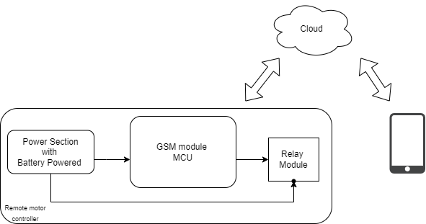

Fig 1: Block Diagram

## Working of Remote Motor Control

The RMC module is used to control the pump ON/OFF via android mobile phone. Device will be connected to the internet through GSM module. Once the customer register with their mobile number, device controlled by user itself.

Features in the device:  
User can get the power status of field.  
Motor controlled by any android/iOS mobile phone

## Requirements

### Hardware

The PCB board having GSM module with MCU which powered by battery. The detailed BOM will be shared.

### Software

The cloud or server to communicate with device and to maintain user detail, firmware will be developed